Lambeth Young Black Men’s Mental Health & Wellbeing: A Co-production Project.
Summary Report

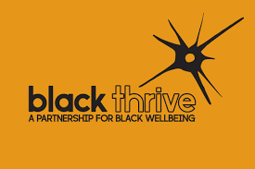
DECEMBER 2020

Acknowledgements
We would like to thank everyone that took part in this project, but in particular the Black men who gave up their time, as well as generously sharing their thoughts and opinions about how services can better meet their needs. We also acknowledge our responsibility as practitioners to amplify their voices to bring about meaningful change.
Taiwo, Sadiki & Chanelle

Introduction
This project was a collaboration between the Mental Health Promotion Team and Black Thrive, focusing on gaining a clearer understanding of the interventions that young Black men themselves would find beneficial for their wellbeing, and feel comfortable using. The project consisted of three phases – gathering the views and ideas from young Black men in Lambeth, and professionals who work with them; analysing the data collected using a qualitative methodology (thematic analysis) as well as using this data to produce a survey to ascertain which intervention Black men felt would be most helpful; and presenting the findings to the young Black men that took part in order to design the specifics of the chosen intervention.
The project team consisted of Taiwo Azeez, Research Assistant (Mental Health Promotion Team), Sadiki Harris, Communications Lead and Community Engagement Worker (Black Thrive), and Dr Chanelle Myrie, Project Lead (Mental Health Promotion Team).

Organisations involved

South London and Maudsley NHS Foundation Trust (SLaM): Mental Health Promotion Team
SLaM’s Mental Health Promotion Team works in partnership with Clinical Commissioning Groups, third sector organisations, NHS services, local authorities and the private sector to provide preventative well-being strategies and raise awareness about early detection and the promotion of meaningful living. The service engages with local workforces and communities to deliver mental health and well-being interventions and workshops, evaluation and research projects and community development initiatives.

Black Thrive
Black Thrive is an independent partnership of Lambeth communities, statutory organisations and voluntary and private sector organisations. They work together to reduce the inequality and injustices experienced by Black people in mental health services in Lambeth. They address the barriers which lead to poorer outcomes across a range of social factors, such as education, employment, housing, all of which may negatively impact health and wellbeing.

Project context and rationale
Despite the well documented mental health inequalities faced by Black communities in the UK (e.g. NHS Digital, 2018; Lavis, 2014; Bradby, 2010), there is an absence of research that aims to address and improve the mental health for members within this community. This lack of attention only serves to contribute to existing problems of overrepresentation in coercive settings, hard to access services, poor engagement and low satisfaction with services experienced by Black communities (Mental Health Foundation, 2016). Black adults have been found to have the lowest treatment rates of any ethnic group (6.2% compared to 13.3% White British) (Mental Health Foundation, 2016) and are more likely to end up in crisis care (Race Equality Foundation, 2019). In addition, figures have shown that Black, Asian and other ethnic minority groups are over-represented at each heightened level in the psychiatric process and are more likely to be treated as inpatients (Lambeth Black Health and Wellbeing Commission, 2014).
The London borough of Lambeth is particularly recognised as a borough facing growing socio-economic inequalities that disproportionately affect people from Black African and Caribbean backgrounds (Black Thrive, 2020). Lambeth has the highest number of Black people accessing mental health services in the UK (Black Thrive, 2020). Whilst 26% of people in Lambeth identify as Black African or Caribbean, 50% of residents in high secure, and 67% in low and medium secure psychiatric detention are of Black African or Caribbean descent (Lambeth Black Health and Wellbeing Commission, 2014).
Outcomes for Black men are especially concerning with men nationally 17 times more likely to be diagnosed with a serious mental health illness and sectioned under the Mental Health Act compared to their White counterparts (Lambeth Black Health and Wellbeing Commission, 2014). Accessing mental health services and treatment is continuously problematic with Lambeth’s Improving Access to Talking Therapies (IAPT) recognising the difficulties of providing a service to young Black men in particular when accessing primary mental health care (Lambeth Integrated Talking Therapies Service Evaluation, 2012).
This summary of findings highlights the urgent need for more evidence based research and interventions to address the ongoing disparities experienced by Black communities both in Lambeth and across the UK.

Aims of the project
The Lambeth Young Black Men’s project was commissioned by Lambeth Clinical Commissioning Group (CCG) as a way of promoting service level change through community based projects. By strengthening the evidence base in this way, such initiatives also support the importance of proactive and preventive public mental health approaches which focus on marginalised communities (Mental Health Taskforce, 2016). This project was designed to contribute to the limited well-being research, in order to highlight effective strategies for both prevention and earlier help-seeking for individuals within Black male communities.
The project aimed to amplify the largely absent voices of Black men in mental health research and address the notable absence of young Black men from early help-seeking pathways. Using a co-production design, we sought to hear the views of Black men directly about perceptions of their own mental health and wellbeing, and what they believe would be helpful in supporting the wellbeing of Black men in Lambeth. Our task was to identify a range of ideas for subsequent mental health interventions to be commissioned by Lambeth CCG and demonstrate how statutory and third sector organisations can effectively work in partnership to support co-produced service development initiatives.
Figure 1. Phases of Young the Lambeth Black Men’s Project.
Co-production between professionals and communities has been shown to be highly effective in generating new insight and knowledge into the conditions that produce and sustain mental health difficulties for individuals and groups (Mental Health Taskforce, 2016). Defined as a “relationship where professionals and citizens share power to plan and deliver support together” (NEF, 2013. p.3), a co-productive model was used in this project to ensure that any intervention designed and delivered was wholly representative of the needs of Black men.

Project Questions
The aims of the project were as follows:
- How do Black men talk about themselves and how does this aid the understanding of their wellbeing?
- How do Black men and ‘professionals’ talk about wellbeing and mental health?
- What are the possibilities for mental health and wellbeing interventions for young Black men?

Phase One - Interviews and Focus groups

Method
The project team designed an approach which would obtain the ideas and opinions of as many young Black men as possible. As the experiences and conceptualisations of young Black men are not monolithic, we chose to host different groups for young Black men to express their thoughts and perspectives. Participants were grouped into three categories; Black men aged 18-25, aged 26-35, and those identifying as Gay, Bisexual, Transsexual or Queer/Questioning (GBTQ+). All participants reported their ethnicity as Black British, Black African, Black Caribbean or Mixed Black African and White. A fourth group was made up of individuals who work professionally with young Black men in Lambeth in community based voluntary sector settings. A qualitative research design consisting of semi structured interview schedules were designed by the project team in accordance with the project’s main questions. Participants were invited to take part via a number of different routes – including social media, connection with local community organisations, and distributing flyers within the borough. A range of focus groups and individual interviews were held over a period of 4 months, and a total of 24 people took part. All interviews were conducted by members of the project team, with an additional facilitator consultant contributing to the GBTQ+ focus group and an individual interview. A thematic analysis (Braun & Clarke, 2006) was conducted on the transcripts to explore the themes across all discussions.

Findings
Three themes and related sub-themes were highlighted from the interviews and focus groups in response to the project’s questions. Suggestions of helpful strategies and interventions were also identified.
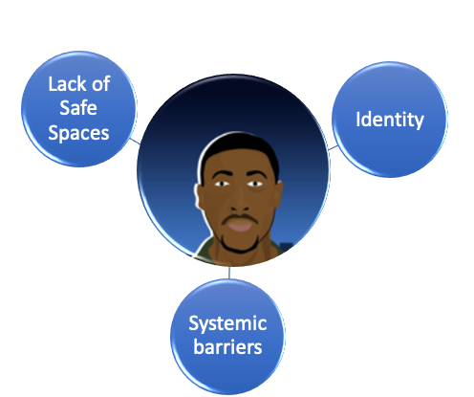
Figure 2. Main thematic areas across interviews and focus groups.

A lack of safe spaces for Black men
For the Black men that we interviewed, being able to engage in activities that supported their wellbeing (particularly in relation to talking about wellbeing), was strongly related to the perceived accessibility of the support, and there being a safe enough space in order to do so:
“There is a real power that happens when Black men get together and talk...just being able to express yourself and not be worried about what other people are thinking, so I suppose it’s about creating a safe space”
(YBM participant - professional)
A variety of socio-cultural and socio-structural barriers meant that participants did not perceive existing mental health service structures and provision as viable avenues for help seeking and therefore did not feel safe to navigate wellbeing support for themselves. Safe spaces were identified as individuals or environments in which Black men could be their authentic selves without fear of judgement, and spaces and/or people that were respectful, understanding and embracing of their cultural identity and background as Black men. When safe spaces were available to Black men, they stated that they felt able to make connections and relate with peers and practitioners.

Authenticity and Relatability
“I guess it’s easier for you to be able to express the difficulties you are going through when you know the person on the other side of the chair will definitely understand where you are coming from but that is not the reality for the world that we are living in right now”
(YBM participant – individual aged 25-35)
The Black men we spoke to shared their feelings of fear, suspicion and scepticism regarding existing mental health pathways and services and their inability to understand the Black male experience. Experiences and perceptions of institutional racism meant that participants were highly resistant to accessing support through fears of being misunderstood and the possibility of not speaking to someone whom they felt they could connect with and relate to. Safe spaces for Black men included being sure that they could encounter services that were free of prejudice and where they would be met with authenticity, and someone that they could relate to, which for most participants meant having access to practitioners who were from the same or similar cultural and/or ethnic background.

Vulnerability
“Vulnerability in Black people seems to be different than vulnerability in White people... we’re not allowed to express certain emotions. So anger within even a therapy space might be difficult for a white therapist to negotiate because they’re so used to this idea that there’s Black and angry people and we should be afraid of them and that they should be suppressed or controlled because it could get out of hand. I think there’s elements around how staff see the people on the other side, in the same way there’s class differences as well between the staff and the people that are seen. That gets in the way too”
(YBM participant– GBTQ+ focus group)
Black men spoke of the difficulties in it being safe to be emotionally vulnerable both within their local communities (including with friends and family) and when accessing mental health services as they are currently offered. The lack of safe help seeking avenues within their support systems and networks sometimes led to coping strategies that were seen by the men as negative or detrimental to long term health and wellbeing. An increased sense of stigma in experiencing distress appeared connected to a sense of having to remain stoic in the face of vulnerability and marginalisation. This mirrors the context of Black communities generally, irrespective of mental distress, given the socio-economic realities for most Black communities.
Additionally, Black men spoke of feeling unsafe and/or fearful of fully expressing emotions in therapeutic settings facilitated by White practitioners who may not be able offer spaces for Black men to safely express and process a full range of unfiltered emotions when responding to life experiences and traumas particularly around experiences of discrimination or racism.

2. Systemic barriers
The ways in which Black men talked about their wellbeing needs and the potential to receive support highlighted a disconnect between how Black men would like to access support, and how services are currently constructed.

Entry to help-seeking being the GP’s surgery
“Ok, personally I don’t think it’s something I would consider even though I know definitely know it… it's something that would be done. I don’t know why I wouldn't consider it. I don’t think it’s something that I would, ok I'm feeling like this, let me go to my GP, it’s not something I would do. Why I don’t know. I'm not 100% sure why I wouldn’t.”
(YBM participant – Individual aged 25-35)
There was an overwhelming sense that going to the GP in the first instance was not something that Black men felt comfortable doing - in fact, several participants were not aware that this was indeed the established pathway to receiving support for mental health difficulties. GP support was closely associated with medicalised treatments for mental distress, which overwhelmingly was rejected by most of the Black men who took part in the project. Many participants reflected on their own relationship with their current GP and the likelihood that their GP wouldn’t share their ethnic background, which would make it either more difficult or in some cases impossible to openly speak about mental health difficulties. It appeared that continuing to rely on accessing support for mental health difficulties via the GP surgery creates additional barriers to help-seeking for Black men, and that alternative pathways would increase help-seeking.

Medicalised narratives of help-seeking
“I think there should be, especially for Black people, a wellbeing hub that is not focused on prescription based drugs. If it is that then fair enough, if you really need that then do that. But I feel like it should be more centred around maybe cooking, your lifestyle, food, yoga.”
(YBM participant - GBTQ+ focus group)
The majority of the young Black men interviewed connected help-seeking for mental distress with receiving prescription medication, which many of the participants were vehemently opposed to. This position can be made sense of in the context of the well documented issue of Black men being more likely to be subject to higher doses of medication within the mental health system (Rabiee & Smith, 2014). GPs were seen as solely as dispensers of medication, or as being more likely to prescribe medication than considering other potentially useful interventions. Medication was also seen as an intervention which was culturally incongruent – participants spoke of the cultural importance of food (including herbal remedies), and exercise as important but less present in medicalised conceptualisations of mental health and wellbeing. As such, continuing to focus on medical models of mental health and interventions could be seen as detrimental to promoting help-seeking for wellbeing issues in young Black male populations.

Organisational structures
“The government is not going to pay, like, people who have been to jail to come and talk to young people like us”
(YBM participant, 18-25 year olds focus group)
As mentioned in the ‘Authenticity and Relatability’ theme above, young Black men spoke of the importance of being able to connect to the person they are speaking to when accessing support for their wellbeing, particularly those speaking from lived experience. However, in some cases they were aware that the people that they might find it supportive to connect to might be people who are marginalised or demonised in society (for example, people who have been to prison). Being able to offer support creatively, and in particular stepping away from more traditional but less accessible forms of support will necessarily involve a systemic change in how health care professionals view what support for wellbeing should look like and who should be offering it.

3. Identity
The Black men we spoke to described the socially promoted ‘ways of being’ for Black men, and how these narratives affect their wellbeing in a range of different ways.

Sociocultural scripts of masculinity
“With Black men there is a fear of looking weak amongst each other. Because there is that fear, "I don't want to look like a weakling. I'm not this, I'm not that, they don't want to show that vulnerability in front of each other.”
(Professional, focus group)
Awareness of dominant constructs of masculinity appeared to play an important role in influencing help-seeking behaviour and governing the responses Black men had in regards to trauma and stress. Both individuals working with Black men and Black men themselves spoke of the protective function of appearing ‘tough’ and ‘resilient’ and being able to manage distress independently. This led to conversations of alternative methods of help-seeking which might be useful but not leave Black men feeling exposed to marginalisation from others. It is also important to mention that the vast majority of the men that took part in the interviews and focus groups felt help-seeking was a useful way of supporting wellbeing needs, rather than this being inherently incompatible with masculinity.

Sexual Orientation & Marginalisation
“I think it is frustrating when you are trying to get help and then you’re getting help but it is from people that you don’t fully feel like you can relate to, you don’t feel like they’re fully going to understand you. The whole thing of just not always feeling like you can be your true authentic self, than in itself, I feel plays a big toll on your mental health, because that is the case when you’re Black and you’re gay.”
(YBM Participant, GBTQ+ focus group)
The intersection of being Black and GBTQ+ further and significantly restricted the available safe spaces and opportunities to receive appropriate mental health and wellbeing support. Black GBTQ+ men spoke of feeling largely unseen and unheard, highlighting the lack of acceptance that can exist from both the Black community and the White GBTQ+ community. As such, having separate spaces for Black GBTQ+ men to attend to mental health (e.g. Black gay hub) was identified as a way of ensuring safety when help seeking.

Phase Two – Online Intervention Survey

Method
Intervention suggestions from the interviews and focus groups were collated, giving 34 suggestions for different wellbeing interventions in total. Members of the project team designed a survey incorporating these suggestions as well as demographic information using the survey programme ‘Qualtrics’. The Black men who took part were invited to vote for their preferred interventions in an online anonymous version of the survey, by ranking the interventions in order of personal preference. In addition, the survey was circulated via social media in order to reach a wider audience – Black men of all ages were invited to participate. 54 Black men completed the survey ranking their preferred intervention choices. The results of the survey were collated and are summarised below.
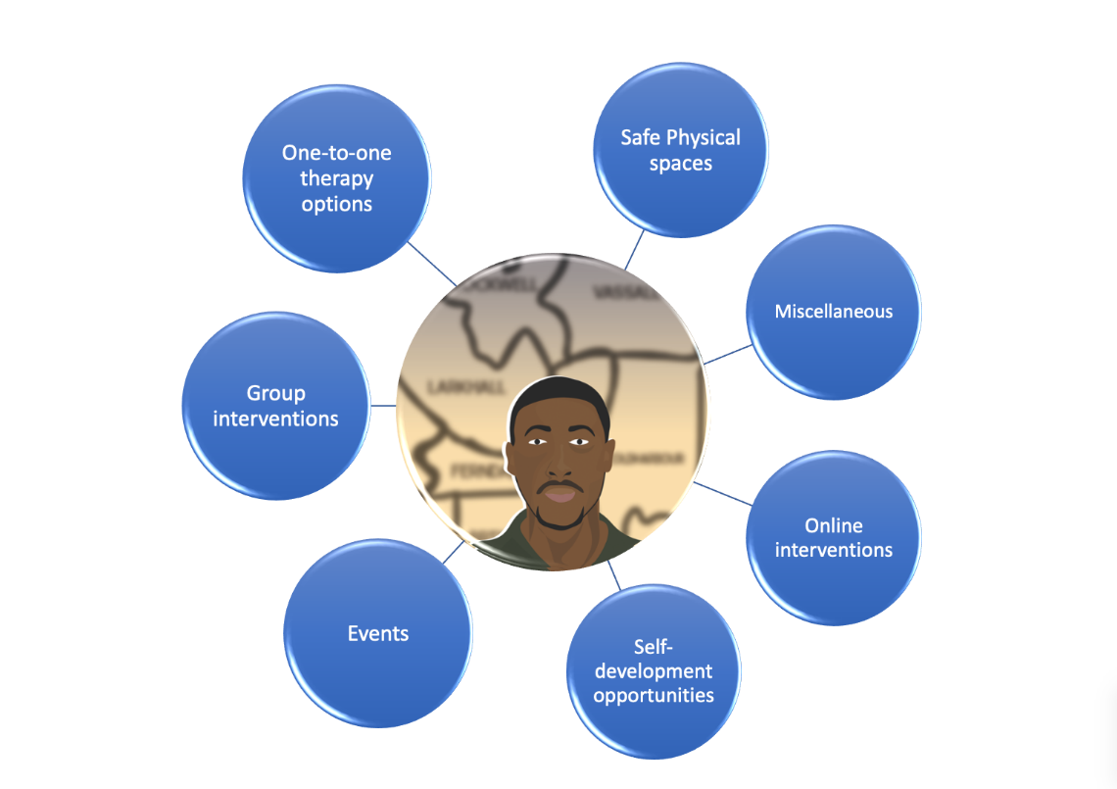
Figure 3. Intervention categories for Black men

Survey results
Order of ranking | Intervention choices
1 | Individual therapy
2 | A Physical activity group (e.g. football, gym)
3 | A group about mental health knowledge/knowledge
4 | Wellbeing retreat – time away from London
5 | Individual therapy followed by group led by the same therapist
6 | Someone who phones you occasionally to check in
Table 1: The top 6 ranked intervention suggestions from the online survey.

Individual therapy was voted as the most popular preferred intervention choice across all options. When spoken about at the individual interview and focus group stage, it was felt that speaking to someone confidentially in a one-to-one setting was important particularly for someone who is seeking help for the first time. Having options regarding the type of therapist (i.e. gender, ethnicity) and the number of sessions was important and having therapy sessions located in a non-clinically venue/setting was essential (if not delivered online). Having ongoing support after therapy in the form of a support group or ‘check ins’ from a therapist or facilitator/wellbeing practitioner was an idea that was well endorsed, with participants wanting some type of ongoing aftercare and support that kept them ‘connected’ to others after the main intervention has finished.

Phase Three – Intervention co-design session

Method
Five of the men who participated in phase 1 of the project returned to attend an online focus group to provide their views on how the mental health/wellbeing intervention should be designed to meet the needs of Black men, and what factors would be necessary to make the delivery of the intervention successful. The key themes from the focus group discussion are outlined below.

Findings

Strong marketing & advertising: Hearing and seeing their own stories
For the intervention to successfully reach and engage Black men, a strong and targeted advertising campaign/s that are Black and male specific was identified as crucial, with images and stories that are relatable to and reflect Black male mental health and wellbeing narratives. Effective marketing and tailored advertising was seen as essential in destigmatizing mental health support and normalizing help seeking narratives within the Black male community. Whilst marketing in all forms was identified as important (for example using leaflets, magazines, business cards) the effective use of social media platforms was identified as essential and particularly necessary when targeting younger Black males. Examples of advertising included online YouTube videos that dispel negative perceptions of therapy by showing positive imagery and videos of therapeutic interactions with Black males & therapists. Where possible a steering group of Black men should be involved in the design of any advertising campaigns.

Access to Black Therapists and culturally competent staff
Being able to be seen by a Black therapist was seen as very important for most but not all the men who took part. Where it was not essential that a therapist was Black, Black men wanted to be assured that staff would be able to understand different cultural perspectives and the type of experiences that might be faced by Black men. Having a choice in a therapist’s ethnicity/background and gender before engaging in one-to-one therapy was preferred.

Flexibility & Choice of mental health support options
Whilst individual therapy was voted as the preferred choice overall, Black men were clear that having different intervention options was essential to meet the differing needs of Black men. Having the choice and flexibility to engage with one or multiple interventions was important, with the focus being on the needs of individuals at a particular time. Participants highlighted the importance of the content and expectations of any intervention being highly transparent and made clear from the outset, so that Black men could make an informed choice as to whether to engage.

Providing other routes to mental health support
For most Black men, accessing support for mental health and wellbeing through their GP remained an unlikely route to help seeking and having different ways that they could access help was essential. Having mental health support services attached to other existing services was identified as important way to increase accessibility and knowledge of services, using creative and targeted advertising methods to reach out to Black men in the spaces that they frequent. For example, a therapy service could be advertised in gym spaces, or signposting talking therapies in schools. It was also suggested that therapy could also be offered/signposted though other public services such as the police. This could be used as an alternative to harsher sanctions and also as a way of building better community relationships with these services.

Summary of the project
The Young Black Men’s project has been a fantastic example of the power of community based participatory approaches, and the strength of co-production to produce meaningful changes to support access to appropriate support for mental health and wellbeing. In order to address some of the well documented inequalities that exist for Black men in regards to their mental health, it is of vital importance that we as practitioners are led by the voice and opinion of Black men to inform their own care. Contrary to popular narratives, this project highlighted that Black men do want to talk about their wellbeing, but in a manner that feels safe, authentic and helpful. We were able to not only gather suggestions for what types of interventions would be seen as useful to Black men, but also the form of these interventions – where they should take place, who should be leading them. Such details were seen as integral to the success of the intervention, but traditionally is overlooked within statutory services. From this project, we have collated a series of recommendations in order to continue the work of this project.

Recommendations

Collaboratively creating more culturally informed spaces for Black men:
Co-production as a model should be continuously utilised to inform and create mental health pathways and spaces where Black men feel valued and safe. This requires having diversity of staff within research teams, services and stakeholder organisations to ensure successful working partnerships with Black men. Having credible, relatable Black males, Black professionals, mental health and wellbeing practitioners, and Black males with lived experience to support these aims is essential.

Individual therapy – what it should look like
Although individual therapy was the most popular suggestion, the form in which the therapy should take place was seen as important as the intervention itself. Being able to offer the option of seeing a therapist from the same ethnic background as the client should be provided. Attention should be placed on being able to offer therapy sessions in non stigmatising locations, including virtual sessions.

Other possibilities for interventions
Consideration should be given to offering a range of interventions which Black men have highlighted they would find useful, such as physical activity groups, mental health awareness raising sessions, and wellbeing retreats. The same considerations regarding the form of the intervention should be held in mind in a similar fashion to providing individual therapy – in particular, who is providing the intervention and where it is taking place.

Spaces specific for Black GBTQ+ men
Within the GBTQ+ focus group and individual interviews, the acknowledgement of ‘difference within difference’ was highlighted. A wellbeing intervention for GBTQ+ men will need additional considerations in order for it to feel safe and also address the multi marginalising experiences that GBTQ+ men can face. One way of ensuring this would be to offer wellbeing interventions that are specifically for GBTQ+ Black men, as well as interventions for Black men generally.

Raising visibility
Black men highlighted that narratives and visibility of Black men help-seeking for wellbeing interventions/support needs to become more commonplace in order for them to feel like this is a socially and culturally accepted behaviour for Black men. Many different ways of doing this were highlighted, for example use of social media, advertising, magazine articles etc. Raising visibility should be seen as a wellbeing intervention in itself.

Cultural diversity in the workforce
Given the preference young Black men have for choice, and for speaking to someone who understands their cultural background and experiences, significant efforts should be made to increase the presence of Black mental health / wellbeing practitioners. Training should be provided to practitioners already working in community settings to increase their knowledge and skills in supporting the wellbeing of young Black men.

Culturally appropriate public mental health approaches
Consideration should be given for the development of selective public mental health approaches and campaigns which specifically focus on improving the mental health and wellbeing of Black communities. This should include approaches which highlight awareness of mental health and wellbeing.

Investment and long term commitments
In order to produce meaningful change in increasing help-seeking for wellbeing in young Black men, a long term investment is necessary, which sits within a strategy specifically designed to increase help-seeking behaviour. Many Black men interviewed highlighted the potential dangers of running pilots (including this project itself) which encourage hope, creativity and accessibility, but are short-lived and so become counterproductive.

Further research needed
More research and evaluation should be prioritised in order to build the evidence base for initiatives and interventions that support Black men’s mental health. This is essential to inform continued investment in programmes that will make the biggest impact.

References
Black Thrive (2020). https://www.blackthrive.org.uk Retrieved on 01/12/2020.
Bradby, H. (2010). Institutional racism in mental health services: The consequences of compromised conceptualisation. Sociological Research Online 15 (3) pp6-96.
Community Sense (2013). Lambeth Integrated Talking Therapies Service Evaluation: Final report for Lambeth CCG. http://www.lambethccg.nhs.uk/about-us/Governing-body-members/Board%20Papers/06-11-2013/ENC%20F2%20Talking%20Therapies%20Service%20Evaluation%20Finalv2.pdf Retrieved on 01/12/2020.
Lambeth Black Health and Wellbeing Commission (2014). From Surviving to Thriving. http://lambethcollaborative.org.uk/wp-content/uploads/2014/08/ENC-4.4-BHWB-Commission-Final-Report2-PDF-June-2014.pdf Retrieved on 01/12/2020.
Lavis, P. (2014). The importance of promoting mental health in children and young people from black and minority ethnic communities. Better Health Briefing 33, Race Equality Foundation. http://raceequalityfoundation.org.uk/wp-content/uploads/2018/02/Health-Briefing-332.pdf Retrieved 21/12/2020.
Mental Health Foundation (2016). Fundamental Facts about Mental Health 2016. Mental Health Foundation: London
NHS Digital (2019). Mental Health Act Statistics, Annual Figures 2018-19. https://digital.nhs.uk/data-and-information/publications/statistical/mental-health-act-statistics-annual-figures/2018-19-annual-figures Retrieved 01/12/2020.
New Economics Foundation (2013). Co-production in Mental Health. A Literature Review. Mind and New Economics Foundation: London
Mental Health Taskforce (2016). The Five Year Forward View for Mental Health. https://www.england.nhs.uk/wp-content/uploads/2016/02/Mental-Health-Taskforce-FYFV-final.pdf Retrieved 01/12/2020.
Rabiee & Smith (2014). Understanding mental health and experience of accessing services among African and African Caribbean Service users and carers in Birmingham UK. Diversity and Equality in Health and Care (11),p125-134.
Race Equality Foundation (2019). Racial Disparities in Mental Health: Literature and Evidence review. https://raceequalityfoundation.org.uk/health-care/mental-health-report-published/ Retrieved 21/12/2020.

