Lambeth Adult Mental Health Services
Service user & carer advisory meeting: 30/1/2020

9 people attended the meeting – 3 service users, 3 carers, the Community Matron, the Quality Improvement Peer worker, the Patient & Public Involvement Lead.

Follow up and actions from previous meetings
- A small group of service users & carers with relevant experience will be developed to support the staff member leading the work on the hospital response team and the secure transport policy.
- The initial work to discuss co-production in the inpatient pathway last year was funded through the Lambeth Together Programme and a report was developed.
- Members of the group will be attending the Trustwide Family & Carers Committee Trustwide Service User Committee

Updates
 | Improving inpatient experience. A monthly group continues to meet. Service user and carer consultants are members of this group with clinicians and staff from other Alliance providers. The group is identifying priority areas based on people’s feedback of services
 | People’s experience of activities on the wards. Service user consultants have devised some questions to ask patients about their understanding of the therapeutic and activities programme that is available.
 | Conversations with people in supported accommodation. The second set of visits has been completed, with discussions focussing on care planning & review, peer support and medication. The report is available and the project team will present it at the Alliance Management meeting. They will discuss how this project can be made more systematic.
 | Lambeth Carers Forum At the last meeting the group were invited to review the Guys & St.Thomas’s Hospital mental health strategy. This has been developed with input from a range of stakeholders
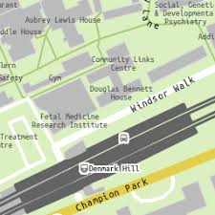 | Changes to Lambeth Hospital site The public consultation is due to start in the middle of February. Group members will be invited to comment on the draft consultation papers. This will be to give feedback on the documents rather than on the proposed changes and is likely to be in the next 10 days
 | Promoting the involvement register There have been 2 events to promote the involvement register to staff and service users. Group members would like to be more involved in this and there is an opportunity to attend a resource fair at MOSAIC clubhouse in March
 | Developing a staying well service Group members have been part of a workshop with staff to develop this new service. A follow up workshop will be run in the near future to take discussions forward.

Quality in the community services
The community matron has recently come into post to oversee the quality of the Lambeth Community Adult mental health services. With the introduction of the Lambeth Alliance this means looking at how the different organisations work together to ensure systems are keeping people safe and well informed as they access treatment & support. Part of the role will be to look at induction and training for staff as they come into the services or as they begin to work more closely with partner organisations. The community matron will also link closely with the work across the trust to oversee quality.
The advisory group suggested that it is really important that people are clear about what they can expect from services and who to contact if there are problems.

Group members will help to devise an induction pack for staff working within the new services.

Trustwide Involvement Groups
Family & Carers Committee A member of the advisory group is now regularly attending this trustwide meeting. At the last meeting there was a talk on young carers, information about carers support on the Maudsley site and an invitation for people to comment on the SLaM Family & Carers strategy.

Quality Improvement Group members are part of large initiatives to improve the way people access the services they need within the boroughs. There are also opportunities for people to get involved in some work on the clinical pathways across the trust .For example the Psychosis Pathway, or the Personality Disorder Pathway. These will be advertised through the involvement register. This work is being organised through the Trusts Quality Centre

Group members would like to find out more about the Quality Centre and how it involves service users and carers in developments.
For more information about the Lambeth Adult Mental Health Service User & Carer Advisory Group, please contact: Alice Glover (Patient & Public involvement lead)
Tel: 020 3228 0959 Email: alice.glover@slam.nhs.uk

Improving inpatient Experience:
- A group will be working in a more focussed way to improve how people experience the inpatient services. They will be looking at specific areas over a period of time and trying out improvements. One of the main areas will developing better understanding about the therapeutic programme and more access to activities on the wards. Members of the advisory group who have experience of the inpatient services will help with this.
- A large Quality Improvement initiative about the processes which happen during a person’s inpatient stay is happening. Service users are part of the group overseeing this.
- Work is being done on the hospital response team - this team works at the inpatient unit to help deal with difficult situations as they arise. There is a policy to make sure that staff work in the most sensitive and safe way. This policy is being reviewed.
- The Trust has agreed a contract with a company to provide “secure transport” for people who need to be moved from one site to another. The advisory group support the commitment to use people carrier cars rather than “cell vans” as this is far more likely to promote dignity and hope of recovery.

A small group of service users & carers with relevant experience will be developed to support the staff member leading the work on the response team and the transport. Support could include developing some good practice guidelines as well as a plan to communicate with staff.

Lambeth Service Director:
Evaluating the Single Point of Access: Members of the advisory group will be talking to people who have used the new telephone service which is the first point of contact with mental health services. They are working with staff to develop a set of questions to see how this service is getting people the help that they need.
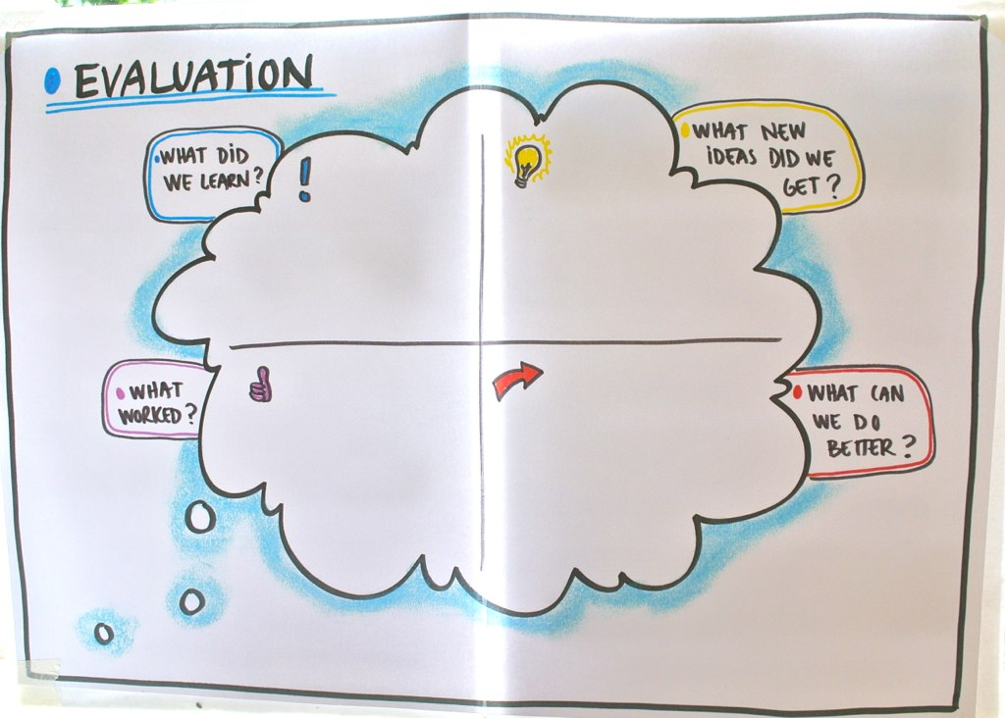
John Lavelle introduced himself as the new Service Director for the Lambeth Adult Mental Health Services. He is responsible for the South London & Maudsley services that contribute to the Lambeth Living Well Alliance. As such, John is keen to have good links with the group seeing it both as a resource and as a group that will hold the executive management team to account. The group raised concerns about the communication that has happened around the changes to people’s service provision with the introduction of new Alliance systems. John acknowledged that communication could have been better.
Going forward. There will be a regular slot at advisory meetings for the service director.
Trustwide Involvement: There are opportunities for service users and carers who are involved in improving services in the boroughs to come together:
- The bi-monthly service user committee
- The monthly family & carers committee
It is important that local issues from the Lambeth Advisory meetings are shared in these Trust wide meetings.

Lambeth Governance Meeting
The group highlighted the importance of keeping service users informed of changes during this time of transition, requesting that this is fed back to the management team.

The advisory group would like to understand more about the budget for and outcome of the work of “We Co-produce” who were commissioned to help develop the inpatient pathway.

For more information about the Lambeth Adult Mental Health Service User & Carer Advisory Group, please contact: Alice Glover (Patient & Public involvement lead)
Tel: 020 3228 0959 Email: alice.glover@slam.nhs.uk

- We will make links with CliniQ – a project promoting health & wellbeing for trans people
- We will look at the SLaM guidance document around gender identity
- Those of us who would like to discuss equalities issues individually will contact the Equalities Manager: Macius.kurowski@slam.nhs.uk

Dates will be circulated and group members will check availability
- We will make links with CliniQ – a project promoting health & wellbeing for trans people
- We will look at the SLaM guidance document around gender identity
- Those of us who would like to discuss equalities issues individually will contact the Equalities Manager: Macius.kurowski@slam.nhs.uk

